MAN NAMIBIAN HERITAGE WEEK 2023 GRANTS
GRANT APPLICATION GUIDELINES

NB: Please read the application guidelines in full before you submit your application.
No incomplete or inaccurately completed applications will be considered.
If you have any queries related to the application form, please contact the MAN office via email at info@museums.com.na or call +26461302230 before the closing date for applications.
Use only the templates provided in the annexures at the end of this document.
The deadline for grant applications is Friday 21 July 2023 at midnight. No late or incomplete applications will be considered.

- WHAT IS NAMIBIAN HERITAGE WEEK
Heritage Week is an opportunity for Namibians to showcase our heritage. The week encourages all Namibians to celebrate and commit themselves to protecting our wonderful natural and cultural resources. Namibia’s major heritage institutions have joined together as a team (the Namibian Heritage Week Team) to organize Namibian Heritage Week. As an umbrella organisation for museums countrywide, the Museums Association of Namibia (MAN) facilitates regional activities through its members during this week.
The theme for Namibian Heritage Week this year is “Heritage and Culture: A Rock-Solid Foundation" in Namibian Sign Language. The Heritage Week Team decided that each year the theme for heritage week will use a local indigenous language as part of our commitment to promoting pride in our cultural diversity. The planned activity should reflect the theme of Namibian Heritage Week.

- WHAT IS THE HERITAGE WEEK FUND?
The Heritage Week Fund is available for MAN’s institutional and associate members who are interested in creating a programme of activities for Heritage Week. The maximum grant that can be awarded to each member is N$10,000, subject to the availability of funds. The grants are being provided this year with funding provided by the National Arts Council of Namibia. We encourage the co-ordination of activities within a region and encourage members to seek partnerships and additional sponsorship for their events.

- IS YOUR MUSEUM/ORGANISATION ELIGIBLE FOR A HERITAGE WEEK GRANT?
Applicants must be fully paid up Institutional or Associate members of the Museums Association of Namibia for the calendar year for which the application is made. Please note that grants are not available to individual members and that no funds will be paid into personal bank accounts.

- WHAT ACTIVITIES CAN BE FUNDED?
Activities that may be funded include, but not limited to:
- Traditional Skills Demonstrations
- Promotional Material
- Temporary Exhibitions
- Activities and Educational Materials for schools
- Storytelling and Presentations
- Guided tours for school groups
- Cultural performances

- WHAT ARE THE GRANT CONDITIONS?
  - All grant applications must be typed. No handwritten applications will be accepted.
  - A museum/organisation should not have any outstanding reports pertaining to previous MAN grants received.
  - Funds must only be spent for the purposes outlined in the Heritage Week Grant Application. Only activities that take place during the Namibian Heritage Week will be funded. (18– 24 September 2023)
  - The MAN and NACN logos should appear on all promotional material produced for the week.
  - Successful grant applicants must submit a full narrative and financial report within two weeks of the end of Heritage Week. The financial report must include the original receipts to account for all expenditure. Any money which is not adequately accounted for must be returned to MAN.
  - In the event that Heritage Week Activities are cancelled, please inform MAN immediately and return any unspent funds.
  - Recording and Live Stream: All activities must be live-streamed (on social media) and recorded. The videos of the recordings should be sent to MAN by the Friday 13th of October 2023 at midnight in video (mp4) format via WeTransfer to info@museums.com.na . Event organizers should ensure that the sound, visuals and lighting are of good quality.
  - COVID-19 Regulations: All events must be in accordance with the National and International COVID-19 guidelines at the time.
  - Catering: In order to help curb the spread of COVID-19, catering and the number of people at the event should be in line with the national COVID-19 restrictions.
  - Translations: All events held in indigenous Namibian languages must be translated into English, on the event recording; either by live translations or with the use of closed captions.
  - Dress Code: All attendees of the events must be required to wear traditional Namibian clothing from any culture.
  - Reporting: A full narrative report accompanied by photographs, original receipts and a budget reconciliation must be sent to MAN by no later than Friday 13th October 2023.
  - Attendance Statistics: The narrative report must include an attendance register which details the following: 1. Total Number of attendees 2. List of names of attendees 3. Gender of each attendee 4. The age bracket of each attendee (0-5 years old, 6-13 years old, 14-18 years old, 19-25 years old, 26-35 years old, 36-45 years old, 46-60 years old, 61+)
  - Hashtags: All posts related to Namibian Heritage Week should include the Hashtags #NHW2023 and #NamibianHeritageWeek2023. The hashtags will enable MAN to collect all the posts across social media posted by both the NHW team and individuals.

- HOW DO I APPLY FOR A GRANT?
Complete the application form, attach all the required documents such as quotations and cost calculations and send it to info@museums.com.na

- HOW ARE GRANT APPLICATIONS ASSESSED?
Each grant application is assessed on its own merits and in the context of other applications, and against the Grant Assessment Criteria listed above.

- WHEN ARE APPLICATIONS DUE?
The deadline for grant applications is Friday 21 July 2023 at midnight. No late or incomplete applications will be considered.

- WHEN WILL WE KNOW IF WE ARE SUCCESSFUL?
All applicants will be notified 1 week after the deadline on Friday 28 July 2023, subject to the availability of the grant review committee.
Successful grant payments will be made on Wednesday 16 August 2023.

- LIST OF ANNEXURES – USE THESE TEMPLATES ONLY
- Annexure 1: Grant Application Form
- Annexure 2: Narrative Report Template (only use for reporting, if you receive the grant)
- Annexure 3: Financial Report Template (only use for reporting, if you receive the grant)
- Annexure 4a: Physical Attendance Register (only use for reporting, if you receive the grant)
- Annexure 4b: Online Attendance Register (only use for reporting, if you receive the grant)
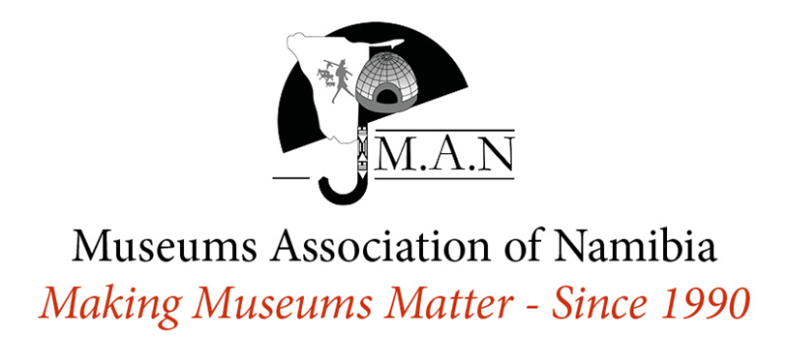
Annexure 1: Heritage Week Grant Application Form
Museum/Institution:
City/Town/Village and Region (where museum is situated):
Contact Person:
Tel:
Mobile:
Email:
Website Link:
YouTube Link:
Facebook Link:
Instagram @:
Twitter @:

VENUE: Where will the activities take place? Please be as detailed as possible.
Name of venue:
Building number:
Street name:
Neighbourhood:
City/Town/Village:
Region:
PUBLICITY: How will your activities be publicised? Name all of the media and publications where your activities and events will be publicised. Written Media (Newspapers), Radio Stations, Social media platforms, etc. and when you will publicise your event.

ACTIVITIES: Please list and describe the activities that will take place during your Heritage Week event. Please be as detailed as possible.

BUDGET: Please provide a breakdown of Costs including costs of items that will be funded from other sources. The budget should be as accurate as possible, and applicants are encouraged to provide quotations.
NB: (Please note that you will be required to submit a copy of ALL your original receipts for funds provided by MAN)
Item Detail | Cost (Number of items x Unit Price = Total Cost)
Budget Total | N$

Annexure 2: Heritage Week Grant Application Narrative Report
Museum/Institution:
City/Town/Village and Region (where museum is situated):
Contact Person:
Tel:
Mobile:
Email:
Website Link:
YouTube Link:
Facebook Link:
Instagram @:
Twitter @:
Year:
Report compiled by:
Date submitted:

ABSTRACT

Summarise the main highlights of your event/activities such as name and type of event/activates, the number and demographics of attendees, collaborations with other institutions, the amount received from MAN plus any additional sponsors etc. (Maximum 200 words) – Delete this instruction when you have finished typing your report.

ACTIVITIES & OUTPUTS
List and detail the event/activities you hosted.

Name of Activity(ies):
Status:
Objectives:
Activity dates:
Detailed Report (Be as detailed as possible):
Output created:
Total Number of Photographs submitted to MAN (minimum 5, maximum 20):
Total Number of Videos submitted to MAN (minimum 1, maximum 5):
Links to online activities (List all the links here):

PARTNERS & STAKEHOLDERS
Use the table below to summarise your relationship with key partners and stakeholders during the preparation and implementation period (Add more rows if necessary):

Partner / Stakeholder | Relationship and Responsibilities

CHALLENGES & LESSONS LEARNED
Detail which challenges you faced, how you overcame them and which lessons you’ve learned as a result. Add more rows in necessary.

Challenge |  | Lesson Learned / Solutions

ATTENDANCE STATISTICS
(NB: Attach the actual attendance Register/Links to the online events that show the views, likes and comments)

Total Number of Attendees
Total Female
Total Male
Total 0-5 years
Total 6-13 years old,
Total 14-18 years old
Total 19-25 years old
Total 26-35 years old
Total 36-45 years old
Total 46-60 years old
Total 61+)

Annexure 3: Heritage Week Grant Financial Report
Museum/Institution:
City/Town/Village and Region (where museum is situated):
Contact Person:
Tel:
Mobile:
Email:
Website Link:
YouTube Link:
Facebook Link:
Instagram @:
Twitter @:

GRANT EXPENDITURE RECONCILIATION
Provide a breakdown of costs funded by the Namibian Heritage week grant. Add more rows in necessary.
NB: (Please note that you will be required to submit a copy of ALL your original receipts for funds provided by MAN)
Item Detail (as detailed in the budget application) | Budgeted Cost  N$ | Actual Cost  N$ | Difference N$ | Explanation of difference (if any)
Total | N$ | N$ | N$

Additional Financial Contributions
Please provide a breakdown of costs items that were funded from other sources. (You do not need to provide receipts for this). Add more rows in necessary.
Item Detail | Cost (N$) | Funding Source
Total | N$

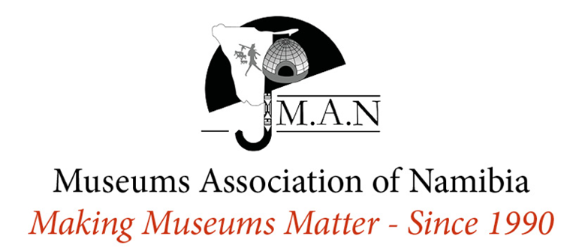
Annexure 4a: Heritage Week Physical Attendance Register
No. | Name & Surname | Gender | 0-5 years | 6-13 years | 14-18 years | 19-25 years | 26-35 years | 36-45 years | 46-60 years | 61+ years

Annexure 4b: Heritage Week Online Attendance Register
Online Platform  (e.g. YouTube, Facebook, IG, Twitter, TikTok etc.) | Link to Post | Total Number of Views | Total Number of Likes | Total Number of Comments

