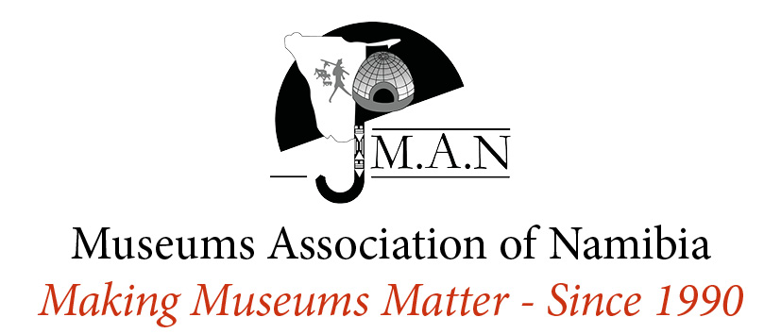
Heritage Week 20 – 26 September 2021 Grant Application Guidelines

- What is Namibian Heritage Week?
Heritage Week is an opportunity for Namibians to showcase our heritage. The week encourages all Namibians to celebrate and commit themselves to protect our wonderful natural and cultural resources. Namibia’s major heritage institutions have joined together as a team to organize Namibian Heritage Week. As an umbrella organisation for museums country wide, the Museums Association of Namibia (MAN) facilitates regional activities through its members during this week.
The theme for Namibian Heritage Week this year is “Feshene; te tlhale e e re lomaganang.” which means “Fashion; the threads that bind us together.” in Setswana. The Heritage Week Team decided that each year the theme for heritage week will use a local indigenous language as part of our commitment to promoting pride in our cultural diversity. The planned activity should reflect the theme of Namibian Heritage Week.
- What is the Heritage Week Fund?
The Heritage Week Fund is available for MAN’s institutional and associate members who are interested in creating a programme of activities for Heritage Week. The maximum grant that can be awarded to each member is N$10,000. The grants are being provided this year with funding provided by the National Arts Council of Namibia. We encourage the co-ordination of activities within a region and encourage members to seek partnerships and additional sponsorship for their events.
- Is your museum/organisation eligible for a Heritage Week Grant?
Applicants must be fully paid up Institutional or Associate members of the Museums Association of Namibia for the calendar year for which the application is made. Please note that grants are not available to individual members and that no funds will be paid into personal bank accounts.
- What activities can be funded?
Activities in the following categories might be funded:
- Traditional Skills Demonstrations
- Promotional Material
- Temporary Exhibitions
- Activities and Educational Materials for schools
- Storytelling and Presentations
- Guided tours for school groups
- Cultural performances

- What are the grant conditions?
  - All grant applications must be typed. No handwritten applications will be accepted.
  - A museum/organisation should not have any outstanding reports pertaining to previous MAN grants received.
  - Funds must only be spent for the purposes outlined in the Heritage Week Grant Application. Only activities that take place during the Namibian Heritage Week will be funded. (20– 26 September 2021)
  - The MAN logo should appear on all promotional material produced for the week.
  - Successful grant applicants must submit a full narrative and financial report within two weeks of the end of Heritage Week. The financial report must include the original receipts to account for all expenditure. Any money which is not adequately accounted for must be returned to MAN.
  - In the event that Heritage Week Activities are cancelled, please inform the Operations Manager immediately and return any unspent funds.
Due to the COVID-19 Pandemic, each institution that receives this grant will be required to comply with the following additional stipulations;
  - Recording and Live Stream: All activities must be live-streamed (on social media) and recorded. The videos of the recordings should be sent to MAN by the Friday 15th of October 2021 at midnight in video (mp4) format via WeTransfer to info@museums.com.na . Event organizers should ensure that the sound, visuals and lighting are of good quality.
  - COVID-19 Regulations: All events must be in accordance with the National and International COVID-19 guidelines at the time.
  - Catering: In order to limit the number of people at events (to help curb the spread of COVID-19), catering must be limited to 10 (ten) people per event – The number of people at the event should be in line with the national COVID-19 restrictions. If individuals will be eating at the event, they must be seated 1m apart, the food must be pre-dished and there shall be no sharing of tables. In order to cut down on the cost for catering, all grantees should either get catering within the approved funds, provide only light refreshments or drinks or buy supplies and self-cater the events.
  - Translations: All events held in indigenous Namibian languages must be translated into English, on the event recording; either by live translations or with the use of closed captions.
  - Dress Code: All attendees of the events must be required to wear traditional Namibian clothing from any culture.
  - Reporting: A full narrative report accompanied by photographs, original receipts and a budget reconciliation must be sent to MAN by no later than Friday 15th October 2021.
  - New Condition for 2021 - Hashtags: All posts related to Namibian Heritage Week should include the Hashtags #NHW2021 and #NamibianHeritageWeek2021. The hashtags will enable MAN to collect all the posts across social media posted by both the NHW team and individuals.

- How do I apply for a grant?
Complete the application form, and attach all the required documents such as quotations and cost calculations and send it to info@museums.com.na

- How are grant applications assessed?
Each grant application is assessed on its own merits and in the context of other applications, and against the Grant Assessment Criteria listed above.

- When will we know if we are successful?
All applicants will be notified 2 weeks after the deadline on 23 August 2021.

- When are applications due?
The deadline for grant applications is Sunday 08 August 2021 at midnight. No late applications will be considered.

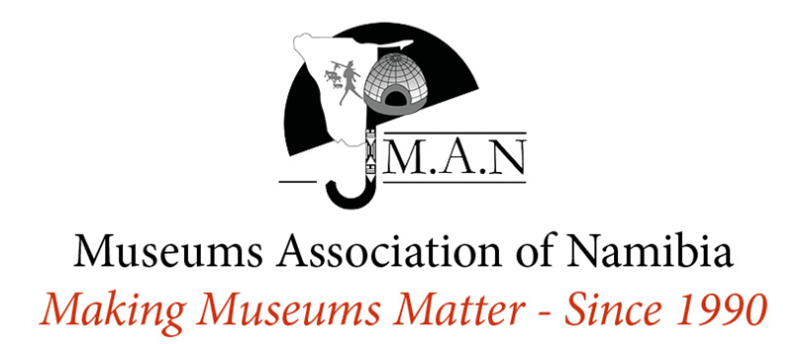
Heritage Week Grant Application Form
Museum/Institution:
Region (where museum is situated):
Contact Person:
Tel:
Fax:
Mobile:
Email

VENUE: Where will the activities take place?

PUBLICITY: How will your activities be publicised? Name all of the media and publications where your activities and events will be publicised. Written Media (Newspapers), Radio Stations etc

ACTIVITIES: Please list and describe the activities that will take place during your Heritage Week event.

BUDGET: Please provide a breakdown of Costs including costs of items that will be funded from other sources. The budget should be as accurate as possible and applicants are encouraged to provide quotations.
Item | Cost

(Please note that you will be required to submit a copy of ALL your original receipts for funds provided by MAN)

